Please View us on the World Wide Web at

www.tablevine.com

Group Dining Guidelines

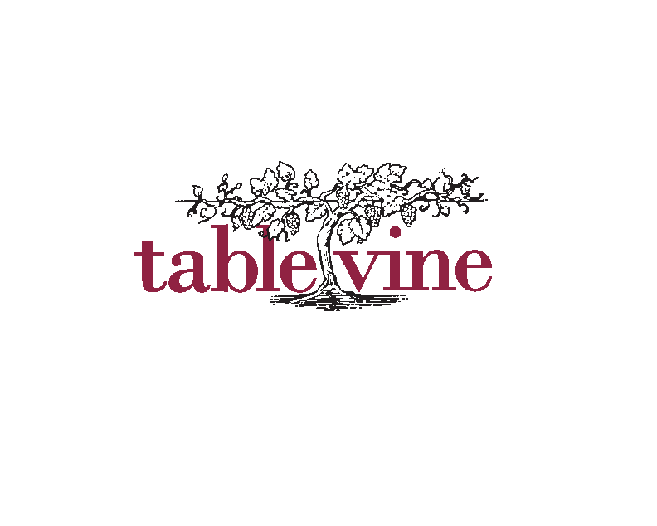

Group Dining Guidelines and Information

Room Capacity Tablevine’s Private Vaulted Barrel Room-Up to 20 for a seated event. ($1000.00 min)
Tablevine’s Main Dining Room-Up to 20 for a seated event. ($1000.00 min)
Tablevine Buy Out. (2000.00 min)

Deposits &
Room Minimum A $300.00 deposit is required to reserve a private dining event at Tablevine.
Private dining requires that a minimum be spent on Food and Beverage. There is a $1000.00 minimum for the Barrel Room.
Lunch the minimums for each are $500.00.

Cancellation Deposits are non-refundable if cancellation occurs within 10 days of the scheduled event. For all events in the month of December the deposit is non-refundable if cancellation occurs within 30 days of the scheduled event

Service Charge and Tax Menus are subject to a 20% service charge and applicable tax.

Menu Planning When planning your menu, please keep in mind that your private dining event is similar to you inviting guests over to your house for dinner. We ask that you choose the same menu for all guests. With seasonality menus and wine availability may change without notice.

Guarantees A guaranteed guest count will be due seven working days prior to the scheduled event. After that date, TableVine can only accept increases in the guest count. TableVine will charge for the guaranteed number of guests or the actual number of guests that attended, whichever is greater.

Payment Final payment is due upon completion of the event. TableVine accepts MasterCard, Visa, Discover and American Express.

Audio Visual Audio/Visual equipment is available through an outside vendor. All audio/visual equipment needs must be arranged prior to the event date.

Menus Menus must be finalized one week prior to the event.

Cake Plating Cake plating fee is $5.00 per person attending the event.

Bar Beverages We offer a full bar and a wonderful selection of wines for the barrel room only. Please limit wine selections to no more that one wine selection per course. Beverages are based on consumption and availability.

Smoking The entire building is a non-smoking facility. Customers choosing to smoke agree to pay for the cleaning of the curtains and any other fines, state or municipal.

Flowers Flowers and floral arrangements are available through us as well as personal consultations with the local floral vendor Kiyos Floral www.kiyosfloral.com
916-446-7236

Directions to TableVine

From Stockton (Northbound) via Highway 5:
Exit O Street heading east.
Turn Left on 14th.
1501 will be on the right side.

From Stockton (Northbound) via Highway 99:
Drive North on Hwy 99 to Hwy 80 West, San Francisco
Drive West on Hwy 80.
Exit 16th Street. Head north on 16th Street.
Turn left on P Street.
Turn right on 14th Street.
1501 will be on the right hand side at the corner of O Street.

From San Francisco (Eastbound) via Highway 80:
Drive East on Hwy 80.
Exit 15th Street. Head east on X street one block.
Turn Left on 16th heading north.
Turn left on P Street.
Turn right on 14th Street.
1501 will be on the right hand side at the corner of O Street.

From Tahoe (Westbound) via Highway 80:
Drive West on Hwy 80 to I-5 South
Exit Q Street. Head east on Q Street.
Turn Right 14th Street.
1501 will be on the right hand side at the corner of O Street.

Please be aware: The city of Sacramento has changed that city parking will be metered until 10:00 PM if you are parked in a metered spot.

Group Dining Menu

Menu items subject to change without notice due to seasonal availability

Lunch

Three Course $55.00 Four Course $65.00

All prices are per person. Tax, service charge and beverages are additional.
All menus, wines and seasonal items subject to change and availability.
Some items subject to additional charge based on cost and seasonal availability.



Starters

Chef’s Selected Hors d’oeuvre

Portuguese Kale Soup with White Beans, Linguica, Potato

Famous Clam Chowder, Applewood Smoked Bacon, Gold Potato, Baby Clams

Caesar Salad with Garlic Croutons and Grana-Padano Cheese

Seasonal Mesclun Green Salad, with garnish and Sherry Vinaigrette



Main Course

Seasonal Risotto featured on the A la Carte Menu

Grilled Pork Tenderloin with Savory Bread Pudding

Slow Roasted Angus Beef Short Rib with Mashed Potato

Fennel Lemon Rubbed Mary’s Chicken Breast

Sauteed California White Sea Bass (or White Fish) Puttanesca Tomato Sauce, Olive, Caper and Anchovy

Oven Roasted Salmon Filet with Pinenut Couscous and Piperade

Dessert

Chocolate Mousse Cake

Lemon Pudding Soufflé Cake

Seasonal Crème Brulee

White Chocolate and Cherry Bread Pudding with Vanilla Sauce

Trio of Sorbets or Ice Cream with House Made Cookies

Group Dining Menu

Menu items subject to change without notice due to seasonal availability

Dinner
Three Course $60.00 Four Course $70.00 Five Course $80.00

All prices are per person. Tax, service charge and beverages are additional.
All menus, wines and seasonal items subject to change and availability.
Some items subject to additional charge based on cost and seasonal availability.



Starters

Chef’s Selected Hors d’oeuvre

Mushroom Strudel with Eggplant Caviar and Black Olive Tapenade

Goat Cheese, Roasted Mushroom and Caramelized Onion Tartlet with Baby Valley Greens



Soups and Salads

Portuguese Kale Soup with White Beans, Linguica, Potato

Caesar Salad with Garlic Croutons and Grana-Padano Cheese

Famous Clam Chowder, Applewood Smoked Bacon, Gold Potato, Baby Clams

Seasonal Mesclun Green Salad, with Garnish and Sherry Vinaigrette

Duck Confit Salad with Frisee, Endive, Greens, Toasted Pecans, Pear and Blue Cheese Vinaigrette



Main Course

Seasonal Risotto featured on the A la Carte Menu

Filet of Beef with Classic Potato Gratin

Grilled Pork Chop Loin with Red Onion Marmalade

Slow Braised Beef Short Rib with Potato

Fennel Lemon Rubbed Chicken Breast with Mashed Potato

Sauteed California White Sea Bass (or White Fish) Puttanesca Tomato Sauce, Olive, Caper and Anchovy*

Oven Roasted Salmon Filet with Pinenut Couscous and Piperade*

*May be served as a main course or smaller fish course



Savory Course

Artisan Cheeses with Thyme Infused Dry Apricot Compote and Toasted Almonds

Blue Cheese Tart with Spiced Almond and Dried Cherry Salad



Dessert

Chocolate Mousse Cake

Lemon Pudding Souffle Cake

Seasonal Creme Brulee

White Chocolate and Cherry Bread Pudding with Vanilla Sauce

Trio of Sorbets or Ice Cream with House Made Cookies (Barrel Room Only)

TableVine’s Hors d’oeuvre Receptions
Menu items subject to change without notice due to seasonal availability



Grilled Eggplant with Olive Tapenade and Goat Cheese

Orange Ginger Prawns

Pulled Pork on Crostini with Chimichurri Sauce

Duck Confit Tostada with Shaved Romaine and Tomatillo Salsa

Soy Marinated Chicken Skewers

Polenta Cakes with Sun-dried Tomato Pesto and Fontina Cheese

Bay Shrimp Ceviche on Tortilla Round

Almond Chicken Salad in Filo Cup

Basil Pesto Risotto Cakes

Sweet and Spicy Glazed Chicken Wings

Seasonal Bruschetta

Hors d’oeuvres Reception Price $6.00 each per person
18.00 Per Person min
Tax, Gratuity and Bar Beverages Additional



Platters

Artisan Cheese Platter $10.00 per person
Charcuterie Platter $10.00 per person
Seasonal Fruit Platter $10.00 per person

TableVine Restaurant 916-942-9599
TableVine Fax Number 916-942-9686
info@tablevine.com
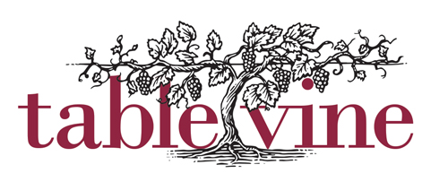
1501 14th Street, Sacramento CA 95814 info@tablevine.com P: 916-942-9599 F: 916-942-9686

Credit Card Authorization Form

I, _____________________________________, hereby authorize the TableVine to charge my credit card account in the amount not to exceed: $
( ) VISA ( ) MasterCard ( ) American Express ( ) Diners Card

Credit Card Number:

Expiration Date: _____ /_____ VID Code: _________

Credit Card Billing Address:

Street:

City: State: Zip Code: _________ - ____

Telephone: ( ) _____-_______

Receipt Faxed to: Fax Receipt: ( ) Yes ( ) No

Fax Telephone: ( ) _____-_______

_____ / _____ / _____
Cardholder’s Signature Date

Service Requested:
( ) Gift Card Amount (min $10.00): Reservation (Name, Date and Time)
( ) Deposit Amount: Event Date, Time, Room:
( ) Dinner Amount:
( ) Bottle of Wine Amount: PDR (up to 28 seats)
( ) Lunch Amount: _

( ) Gratuity: _____15% _____18% _____20% _____ Other
Instructions:

Please attach copy of credit card for our records when faxing back.

